

cBRADFORD NEW DATA ANALYST GUIDE

May 2023
TABLE OF CONTENTS

Page

1. TABLE OF CONTENTS 2

2. INTRODUCTION 3

3. LOG IN AND USERNAME 4

4. PROJECT AND MYSPACE AREAS 5

5. VERTEX/JUPTER 6-7

6. USEFUL LINKS 8

2. INTRODUCTION
Welcome to cBradford.
This guide is aimed at helping you to be able to access the data held in cBradford to complete your project.
The Connected Bradford programme links disparate routine electronic data in an anonymised database across primary care, secondary care, community care and social care for over 700,000 individuals at Bradford Teaching Hospitals NHS Foundation Trust. The digital platform data is integral for the secondary use analysis of data to improve patient pathways of care across the region, re-design models of care, research and evaluation.
The Connected Bradford database is governed by the terms and conditions of the signed data sharing agreements from 86 General Practices across what were three CCGs – Bradford City and Districts and Airedale Wharfedale and Craven, O(now ICSs – Integrated Care Systems), Three trusts - Bradford Teaching Hospitals, Airedale Hospital, Bradford District Care Trust and two Local Authorities, Bradford and North Yorkshire Local Authorities and two Voluntary care organisations. The anonymised data is overseen by the Connected Yorkshire governance committee which has representation from the data providers and the public.
You will be allocated a “buddy” from the Connected Bradford team who will be available for any support you may require.
3. LOG IN AND USERNAME
Once you have received project approval and your Data Sharing Agreement/Contract has been signed:
A call will be logged with our provider PHM and login details will be sent to you from jira@yhcrservice.atlassian.net to be added as a user with a yhcr email address.
See screenshot below:
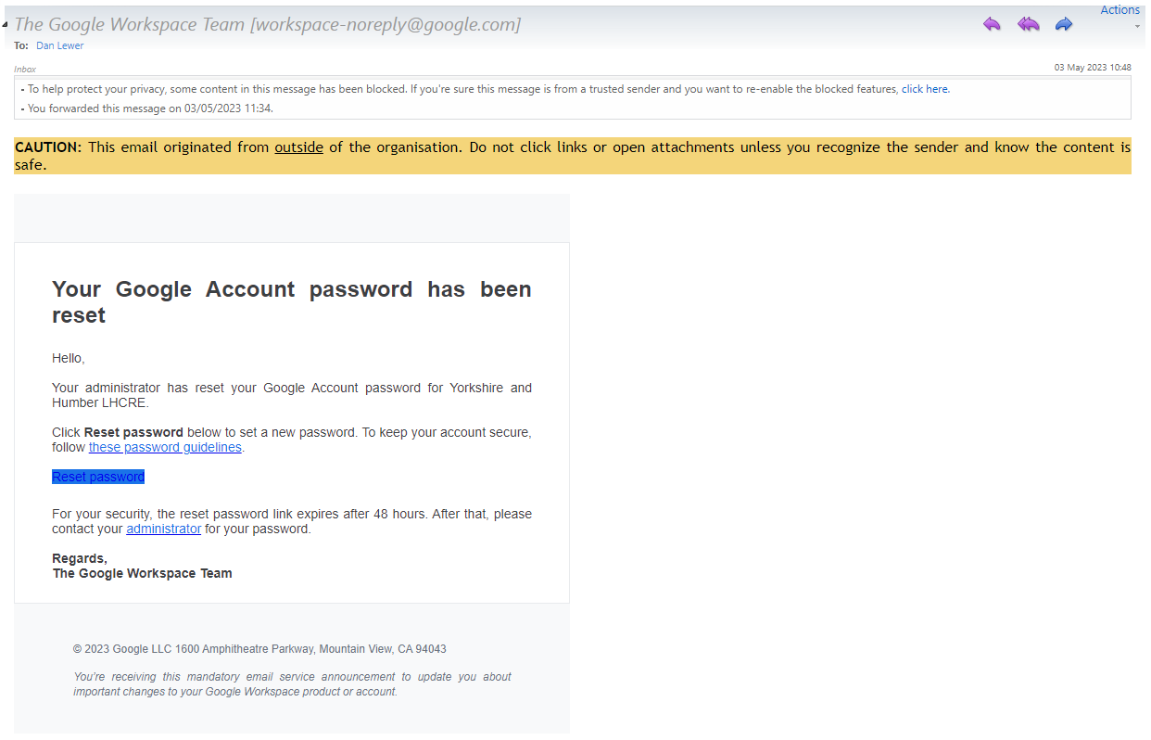
If you receive something similar to this and it comes from Yorkshire and humber LHCRE then it is valid and is part of the CB system so please accept the e mail.
You will require access to a Juypter Notebook (VERTEX) to build your R or Python scripts to access the data
Log in and create a username and password.
You will now have access to the Bradford Google environment. To access the data and run queries etc
You will also require access to a Github account. If you haven’t already got a GitHub account please set up an account and let John Birkinshaw (john.birkinshaw@bthft.nhs.uk) or Cathy Hulin (cathy.hulin@bthft.nhs.uk) know your Github user name.
Documentation relating to Connected Bradford can be found via this link : https://github.com/ConnectedBradford/
4. PROJECT AND MYSPACE AREAS
Once you have logged in and set up your username etc you will be linked to the appropriate dataset you require for your project. You will have two datasets to work with, as well as read access to the datasets containing the source data (dependent upon your project):
- CB_nnnn_aa – This is the project space
nnnn – is our reference number from the system we log your EOI on
aa – You initials , or the lead applicants initials.

This is the dataset in which all outputs for the project must go. This dataset will be retained after the project completion.

- CB_MYSPACE_aa – This is your own space – If required
This is your own workspace allocated for you to work with your data. This is a space in which you can build temporary objects to aid your analysis and learn the tools. You can do whatever you like in this dataset.

5. VERTEX/JUPYTER
To access Vertex click this link, your Notebook will be on this list. An email with a link to your Notebook will be sent separately.: https://console.cloud.google.com/vertex-ai/workbench/user-managed?authuser=2&project=yhcr-prd-phm-bia-core
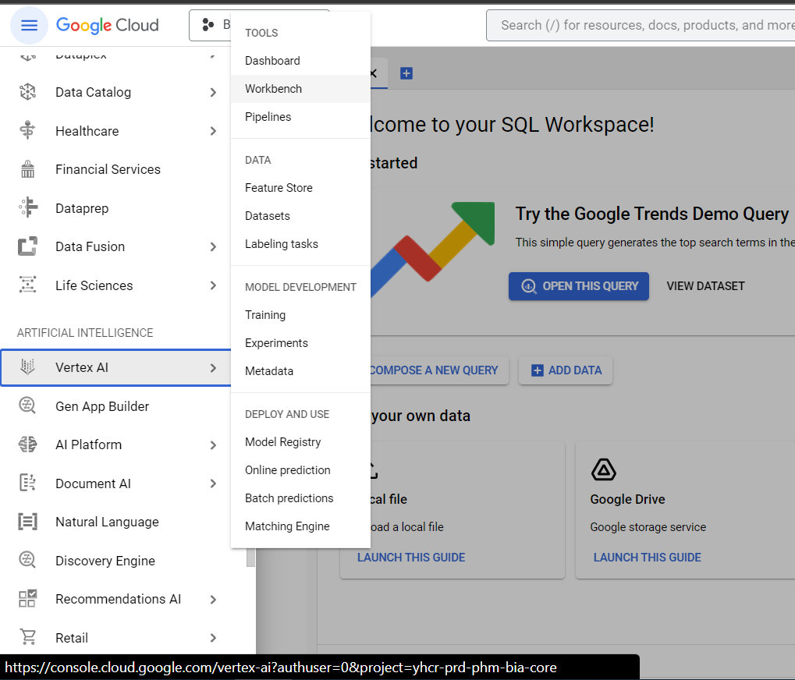
To access Vertex and your Workbench:

1. Click here
2. Scroll down and click Vertex AI
3. Click Workbench

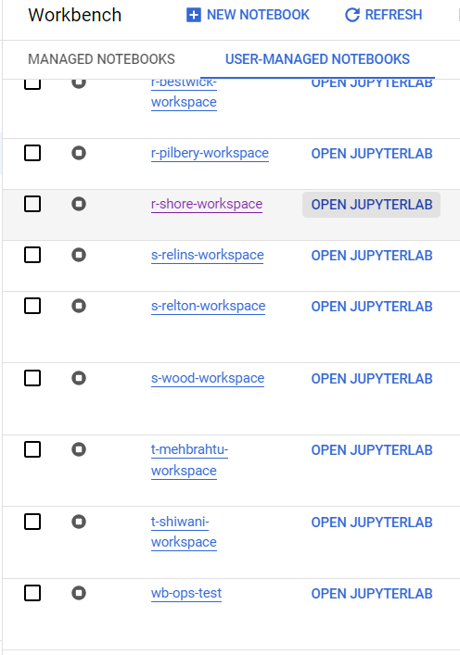
This will take you to the Workbench screen. Scroll down to find your name and click OPEN JUPYTERLAB

This will take you to the JupyterLab launcher where you can begin to set-up your environment
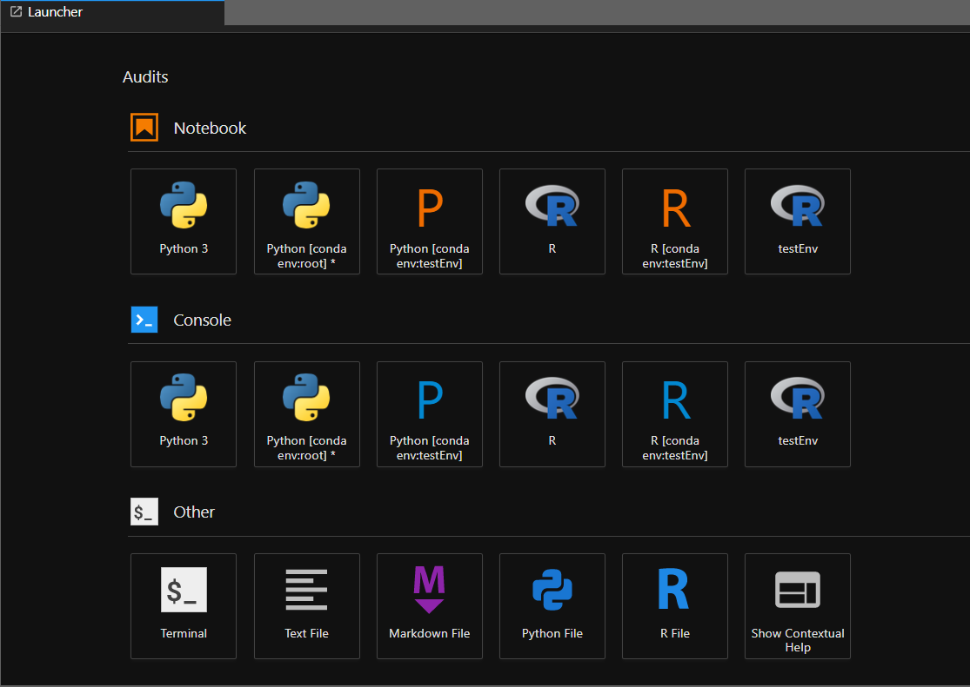

For instructions on how to setup and use VERTEX please see the section : CB_GuidanceForAnalysts on Github.
https://github.com/ConnectedBradford/CB_GuidanceForAnalysts/blob/main/docs/r_vertex_instructions.pdf

To get past the authentication process use this process.
https://github.com/ConnectedBradford/CB_GuidanceForAnalysts/blob/main/docs/Using%20Managed%20Notebooks%20-%20security%20config.doc
6. USEFUL LINKS
https://github.com/ConnectedBradford/CB_GuidanceForAnalysts/blob/main/docs/cBdfd_newstarterguide.pdf
Useful code snippets: https://github.com/ConnectedBradford/CB_GuidanceForAnalysts/tree/main/code

